12月21日研究生进展类讲座（医学）

主讲人： Dr. Ying SUN
King’s College London School of Medicine
时间：2010年12月21日（周二）16：00-17：00
地点：东南大学丁家桥校区综合楼二楼多功能报告厅
主办单位：研究生院
承办单位：医学院
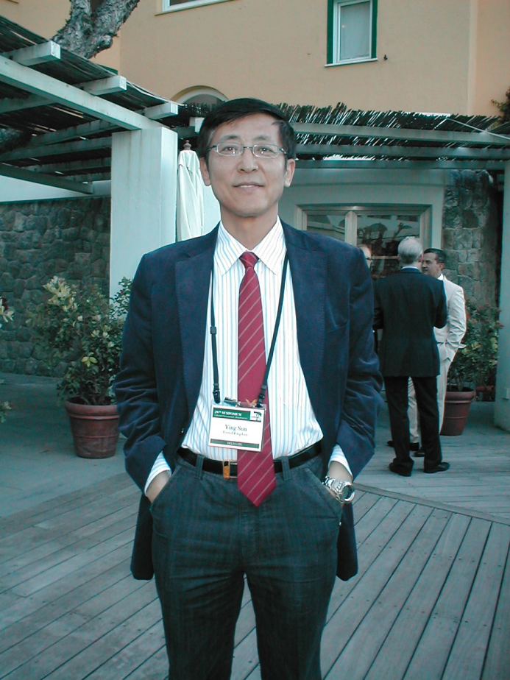

主讲人简介：
School: King’s College London School of Medicine
Department: Asthma, Allergy & Respiratory Science
Research achievement:
- SCI search 175 publications
- ISI search the cited times more than 9000 by others
- More than 90 Original publications, most of which are in prestigious international journals; NEJM 1, JEM 3, PNAS 1, Blood 1, JCI 2, 11 in the top journal of Immunological field-J Immunology, 15 in the top journal of Allergy and Clinical Immunology (JACI).
- Involved in training/supervision of 21 pre- and post-doctoral scientists
讲座内容简介：
Novel roles of IL-25 in asthmatic airways remodelling: what we knew and what we should know:
The previous studies showed that IL-25 (IL-17E) is a Th2 type cytokine best described as a potentiator of Th2 memory responses. Dr. SUN has found increased expression of IL-25/IL-25R in airways of asthmatics compared with controls. In vitro, they found that human blood endothelial cells (HUVEC) expressed IL-25R and IL-25 induced VEGF and VEGFR expression. Biological assay also showed that IL-25 induces in vitro formation of microvascular structures, suggesting IL-25 might contribute to airways remodelling such as angiogenesis. Dr. SUN will give a talk on the novel roles of IL-25 in asthmatic airways remodeling and the related underlying molecular mechanism.

